**Setting up a Debian 10 LAMP Server for PHP Web Development**

### Installing and Configuring MySQL/MariaDB:

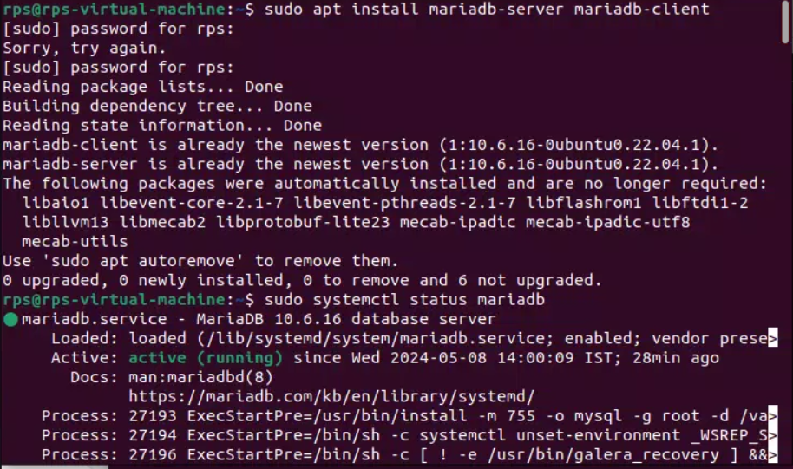$ sudo apt install mariadb-server mariadb-client

To confirm the installation, press **Y** and then press **<Enter>**.

The APT package manager will download and install all the required packages.

At this point, MariaDB server and client packages will be installed.

Now, check whether **mariadb** service is running with the following command:

sudo systemctl status mariadb

As you can see, the **mariadb** service is running. It’s also **enabled** to automatically start on system boot.

If in any case, **mariadb**service is not running, then start the service with the following command:

sudo systemctl start mariadb

sudo mysql_secure_installation

Press **<Enter>**.

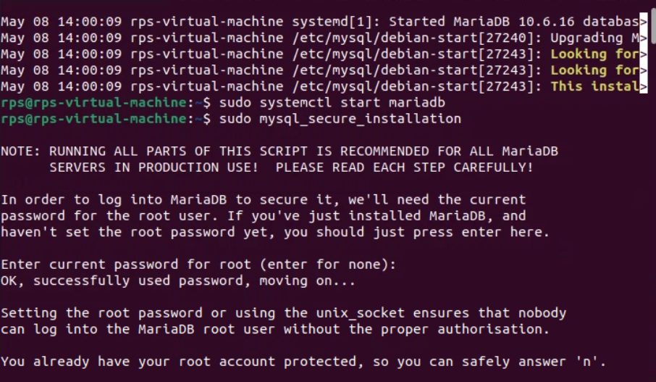

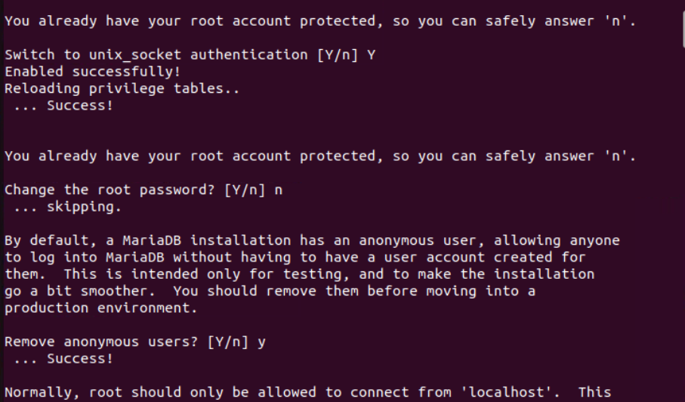

### Creating New MySQL/MariaDB Users and Databases:

sudo mysql -u root –p

Now, type in the MariaDB **root** password you’ve already set and press **<Enter>**.

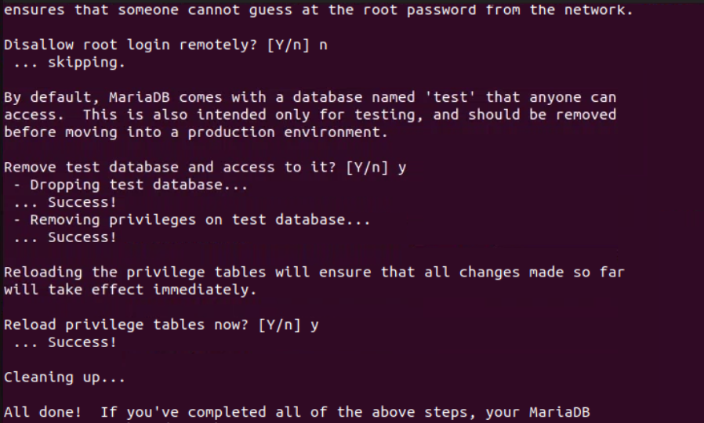

Now, create a database **app1** with the following SQL statement:

CREATE DATABASE app1;

Now, create a new user (let’s say, **shovon**), set a password for the user (let’s say **123**) and grant the user permission to use the database **app1**with the following SQL statement:

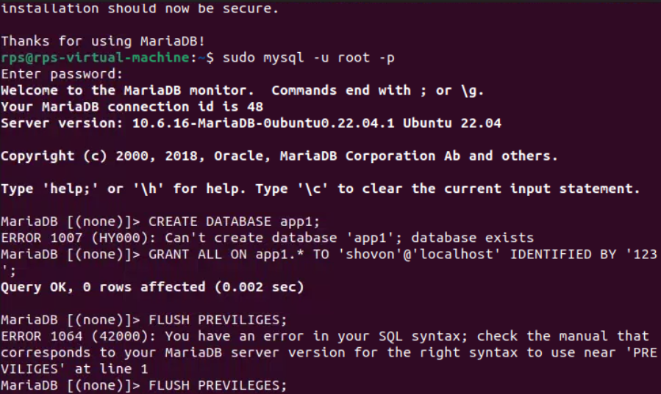

GRANT ALL ON app1.* TO 'shovon'@'localhost' IDENTIFIED BY '123';

FLUSH PRIVILEGES;

Now, exit out of the MariaDB shell as follows:

\q

